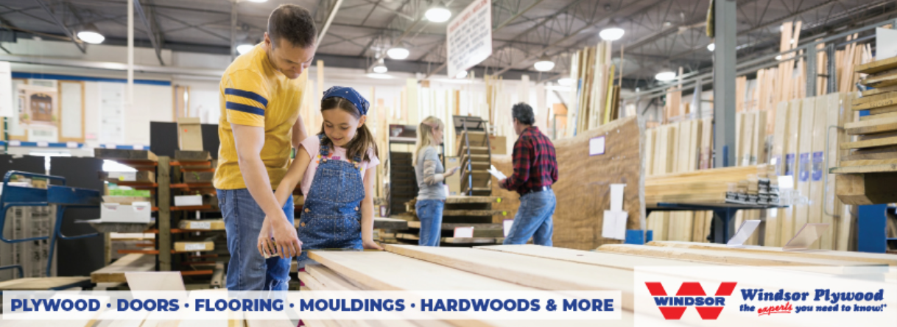
WINDSOR PLYWOOD
Our Stores specialize in hard-to-source interior and exterior home finishing products including flooring, doors, mouldings and specialty wood products. Our business model is also very different as most of our locations are family affairs – independently locally owned and operated – not top-down like most franchise groups. We carry high quality, responsibly sourced products and are committed to providing outstanding value and personalized, one-on-one service to all of our Store Operators. We are proud to have been in business for over 55 years with over 60 stores across Canada and into the Pacific Northwest of the United States.
SUMMARY OF POSITION
Our managers are responsible for directing the overall operation of their location for the proper management of the employees, profitability and assets. Our managers are hands-on and manage the business from the front sales counter. They have a strong sense of business acumen and experience within the Building Material Supply Industry that provides them the ability to serve the markets they reside in. They must be able to make managerial level decisions and are expected to be scheduled and working any time an Assistant Manager is scheduled off. Bonus- there is room for future ownership opportunity!

THE BENEFITS
- Relocation Subsidy
- Stability in the building materials industry
- Autonomy to succeed
- Competitive Pay + Benefits
- Management Training Program
- Build and renovate your home with deep-discounted pricing

PERFORMANCE EXPECTATIONS

Sales
- Initiating and executing sales and marketing initiatives to drive sales at the store level
- Continuously evaluate industry trends and local competition factors that may impact business
- Educating employees to be industry leaders through product knowledge & sales training
- Monitor store’s overall account receivables while supporting collection processes when required
- Supervise merchandise displays and instore promotions to drive store traffic

Customer Service
- Ensure every customer experience exceeds the customer’s expectations – go the “extra-mile”
- Promote features/benefits of all products & services provided – “drive sales”
- Proactively engage, assess, and anticipate the needs of each customer individually
- Develop rapport, follow-up and build strong long-term relationship with customers
- Promote complimentary add-on sales, Door Shop & other instore services
- Answer in-coming phone calls (3-rings), emails & faxes in a professional prompt manner
- Assist with entire sales-cycle – includes retrieving, handling, displaying and loading materials

Operations
- Diligently follow check-lists, policies, processes, procedures & provided guides
- Handle customer problems & complaints in a positive & constructive manner
- Identify defective & damaged products and report appropriately
- Operate equipment as directed by management | forklifts, woodworking machinery, power tools, delivery trucks
- Maintain a high level of orderliness and tidiness in the store and yard
- Ensure shelves and plywood bins stocked, faced and merchandised
- Yard lumber piles are organized and tarped and aisles free of debris and tripping hazards
- Be observant of customers who appear to be acting in a manner of store theft
- Follow OHS company guidelines and maintain a safe & positive work-environment

Employees
- Recruit, hire and terminate employees as necessary
- Provide strong leadership to manage, train and coach employees for continued improvement, top performance and high levels of engagement
- Actively build team through recruitment and internal development – including Supervisors
- Participate in staff coaching, performance reviews and disciplinary matters as required
- Conduct monthly staff meetings to ensure timely and transparent communication with employees

Inventory
- Actively control transactions including daily sales, returns, costs, expenses
- Ensure incoming and outgoing inventory is routinely inspected for damage and accuracy
- Utilize all processes to mitigate inventory shrinkage and product damage
- Proactively evaluate Store inventory levels to ensure sales demand is fulfilled

QUALIFICATIONS & EXPERIENCE REQUIRED
Education Required:
- High School Grade 12 Diploma or Equivalency
- Some additional post-secondary training is preferred
- Ability to identify, source, grade and sell lumber, moulding, flooring and specialty woods

Experience Requirements:
- Minimum 2 years of functional hands-on building material supply experience
- Previous locally-operated retail management experience is advantageous
- Proven successful record of achieving Sales Targets
- Able to use woodworking machinery for minimal routine operation in the Shop
- Permanent resident of Canada with an active Drivers License

Skill Requirements:
- Strong comprehension with verbal and written communication skills in English – as much of the time spent is communicating with customers.
- Strong sense of ownership and accountability – “intrapreneurship”
- Able to deal with changes, delays, or unexpected events in a professional & timely manner
- Self-directed with an ability to work independently using sound judgment, logical reasoning skills, and intuition
- Must be able to manage multiple tasks and have great time management skills
- Flexible, honest, acting in all situations with professionalism and integrity

Physical Requirements:
Positional Tasks
  - Walking 45%
  - Standing 20%
  - Sitting 10%
  - Lifting 10%
  - Carrying(up to 30lbs) 5%
  - Trunk Rotation 5%
  - Pushing/Pulling 3%
  - Stair/Ladder Climbing 2%

GENERAL WORKING CONDITIONS
Required to be available to work Store hours between Monday to Saturday - Key-Holder
Attend Windsor U manager training workshop along with annual manager meetings held at Head Office
Periodic exposure to dust, dirt and adverse weather conditions
Frequently working extended hours to ensure operational targets are achieved
*Position not eligible to work from home




